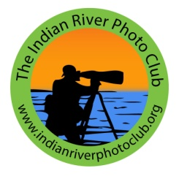
End of the Year 2019 Report
From President, Billy Ocker
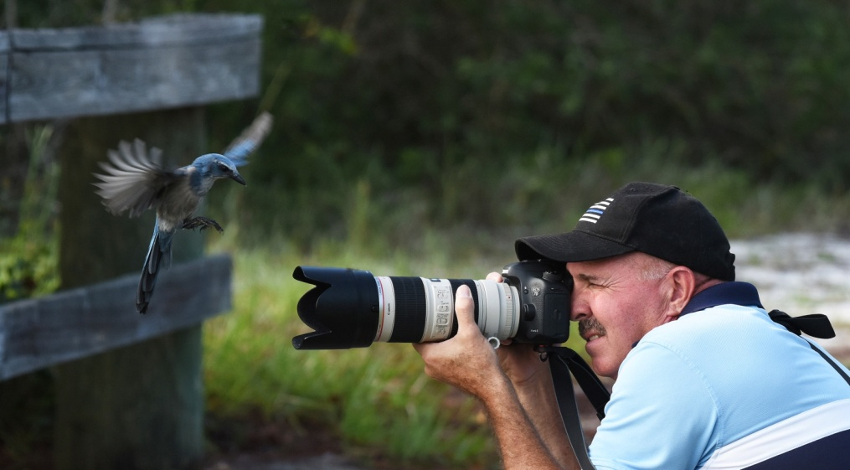

Good end-of-the-year wishes to all Indian River Photo Club Members.

As your president, I am pleased to tell you that as we end this great Indian River Photo Club Year of 2019, your Board Of Director has already been working toward a excellent 2020 year. A number of 2020 monthly meeting speakers have been scheduled and discussions for the future are underway. If any of the members have some positive input, we would like to hear it along with how you think it can be done. Now is the perfect time to submit your ideas and solutions.

Membership
We ended 2019 with 82 adult members. That is approximately an 11 ½ percent increase over 2018 (at this same time of year). A large percentage of our new and returning members are very active and instrumental in the daily operations of the club.
Indian River Photo Club Board of Directors:
Billy Ocker, President
Jerry Merritt, VP
Joyce Burr, VP
Bobbi Whitlam, Treasurer
Tom Doyle, Secretary
Louis Ciszak, Director

Volunteers
Room Set UP/Down for Meetings, Tom Doyle, Jerry Merritt, Skip Murphy, Others
Electronics Set UP/Down for Meeting, Billy Ocker
Snacks, Etta Ocker
Monthly Contest Judges, Billy Ocker
Monthly Contest Manager, Patty Corapi
Program Speakers, Billy Ocker
Outside the Box, J.R. Williams and George Bollis
Advertising, Joyce Burr
F3C Liaison, Bobbi Whitlam
Announcements Power Point, Mary Ester Bollis
50/50 Raffle, Tom Doyle, Skip Murphy, Arleen Willnow
Museum Contest, Tom Doyle
Newsletter Editor, Bill Capie
Web Site Manager, Billy Ocker
Mini Exhibits, Mary Ester Bollis
Meeting Photographer (I.D. Lanyards and Contest winners). Bill Conway
Photo Sharing Slide Shows Coordinators, Bill Conway Bobbi Whitlam & Billy Ocker
BPOY Social, Etta Ocker
BPOY Intake, Bobbi Whitlam
BPOY Judges, Board of Directors
Museum Juried Exhibit Judges, Board of Directors North County Library Photo Exhibit, Joyce Burr

PHOTOGRAPIC MINI EXHIBIT VOLUNTEERS for 2019
Maria Heffernan Brian Drinkwater Frank Frazer Herb Gray Don Hill Susan Grube Alex Melo Nancy Alderman Tom Doyle Cheri Baldwin Joyce Burr Nick Binghieri Mike Steward Sondra Goding Frank Roberts Kathie Philips Jerry Merritt Al Ahearn

Bird-a-Palooza at the March meeting by ALL members.

Program Speakers for 2019 were as follows:
January Kirsten Kowalski Abstract/Minimalist
February Lou Lower The Zone of Awe
March Juanita Baker What Makes a Good Bird Photo
April Janice Broda Photographing Native Wild Flora
May Tom Doyle Composition
June Richard Thomson FUN Photography
July Frank Frazer Manual Camera Settings
August Jim Angy Photographing Sea Turtles
September Dawn Currie Embracing the Possible … When Plans Fail
October Rusty Wiles Abstract-Saturated-Minimalism

2019 Think Outside the Box activities included:
February: Photographing at the largest orchid nursery in Florida, Odoms.
Lunch after at The Golden Coral April: Guided Native Plant Photo Walk with Janice Broda. . Homemade-Cookies Picnic after (at Captain Forester Preserve)

2019 Judges for the Monthly Print Contests
We were honored to have had a number of capable/accomplished photographers volunteer their expertise and time to be judges for our monthly contests: Donna Green Betsy Kurzinger Curtis & Janae Jensen
Anne Malsbary Eric Attas Sondra and Harry Quatraro
Janice Broda Louie Cszak Dick Robertson
Kim Hunt Patty Corapi

2019 North County Library Exhibit (September & October 2019) Joyce Burr collected photographs from various club members and hung them in the entry display case at the exceptionally busy North County Library. The display was seen by all who entered the library and it was a well executed exhibit. Everyone who Joyce Burr showcased can feel proud of how their individual pieces were presented as well as the overall professional look.

IRPC 2019 Juried Print Exhibit
At the time of this report for 2019, we are looking forward to the 2019 Juried Print Exhibit at the Vero Beach Museum of Art.
All needed information is on the Web Site.
This is an especially important activity for our club because it showcases the art of photography to our community and it is published in the Vero Beach Magazine.
Tom Doyle did a great job in 2018 and he is in charge again in 2019.

F3C Convention
Members who attended the 2019 Spring F3C Convention in Fort Myers: Lynne Hollingsworth, Bobbi Whitlam, George and Mary Ester Bollis

Some of the IRPC President’s Goals for 2020
- More members to get involved by volunteering in the club
- Growth in membership
- More activities and seminars
- More participation in the monthly B Class Competitions
- More opportunities for members to become friends and mentors
- More fun!

Respectfully submitted

Billy Ocker, President
Indian River Photo Club

