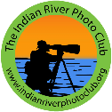
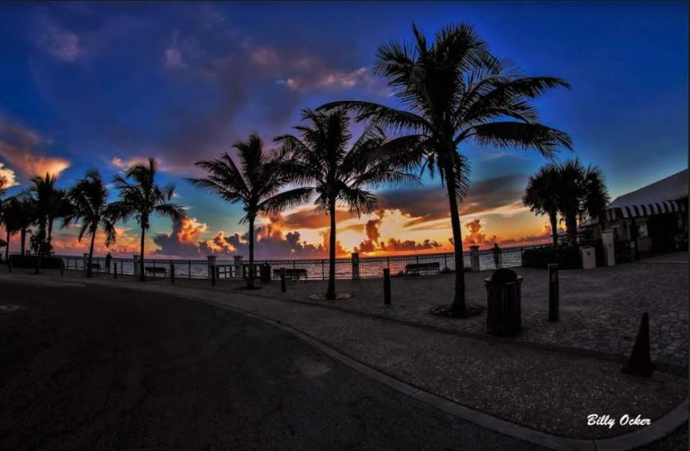
Indian River Photo Club July’s Newsletter 2021

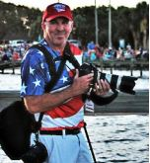

Hello Club Members
I hope everyone had a great 4th of July Holiday and was able to get out there and capture some amazing photos for this month’s Photo Contest Theme “Patriotic”! The clubs next meeting will be July 22nd. All members are welcome and encouraged to enter their photos. It’s good to get back to our monthly meetings. June’s meeting turned out to be a very successful. Thank you to everyone that attended. I would also like to thank David Bence for being Junes Judge, and thank you also to Patty Corapi who assisted. Thank you, Nancy Vandergrift, for providing the refreshments, they were enjoyed by all. If anyone is interested in being on the board, please contact me at postman555irpc@gmail.com . I Look forward to seeing you at the next club meeting.

Keep your camera ready, your flash cards clean, and your batteries charged.
IRPC President - Billy Ocker

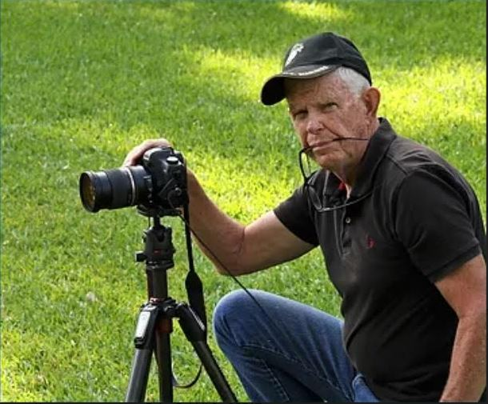
July Program
“Basic Photography “
Meeting Speaker - Tom Doyle

Tom Doyle Bio
United States Marine Corps, 1954 to 1962, four years active duty, Honorable Discharge 1962
Sergeant Rifle Squad Leader
Police Department, City of New York, 1960 to 1993, retired as a Lieutenant
On leave from NYPD 1987 to 1989 served as Assistant Commissioner for Traffic
Enforcement, NYCDOT
On Leave from NYPD 1989 t0 1991 served as Executive Director NYC Medical Emergency
Services
1993 to 2000 worked as an emergency services consultant for various companies that built
computer aided dispatch systems for Police, Fire and Emergency Medical Service agencies
including a two-year job in London, U.K. from 1998 to 2000
2000 to present learning photography and won some awards along the way including 2015
Court of Honor Professional Photographers Society of New York State
B.A. Fordham University 1976, History Major
M.S. Columbia University Graduate School of Business 1980, Operations Research

June 2021 award results THEME: OPEN

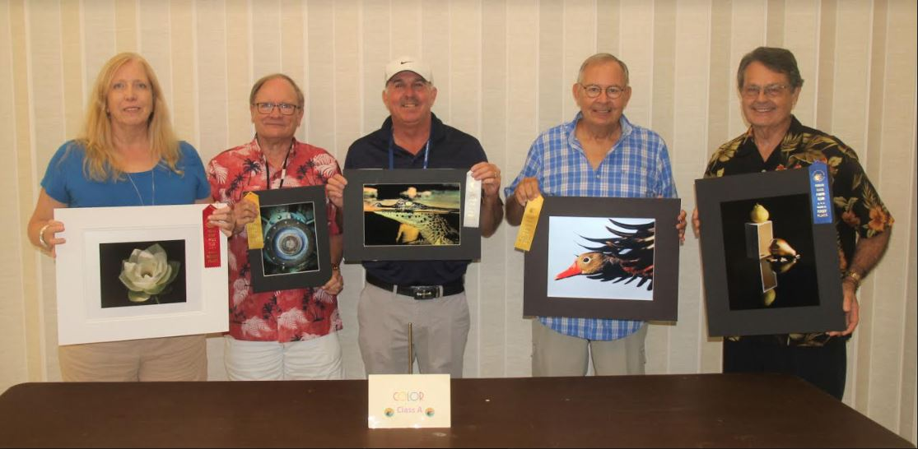
Class A Color
George Bollis “I’ve fallen for you” 1st Place
Lynne Hollingsworth “Green Lotus” 2nd Place
Billy Ocker “Gator Level “ 3rd Place
Jerry Merritt “Black Belly Whistler” HM
Mike Stewart “Blue” HM

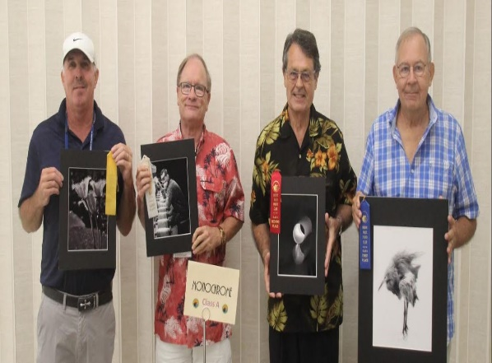
Class A Monochrome
Jerry Merritt “Angry Bird” 1st Place
George Bollis “light at the end of the tunnel” 2nd place
Mike Stewart “Lathe Worker” 3rd Place
Billy Ocker “Water Snowflakes” HM

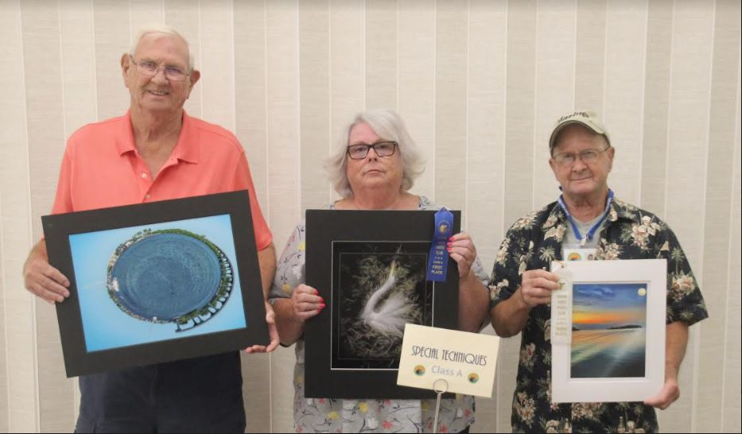
Class A Special Techniques
Susan Grube “Egret Fantasy” 1st Place
Dennis Ekman “ Planet Vero “ 2nd Place
Skip Murphy “ Lagoon Moon “ 3rd Place

Class A: Color

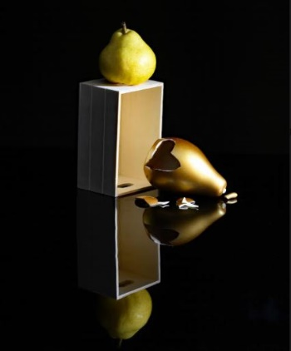

1st Place
“I’ve Fallen for You “ 2nd Place
By George Bollis “ Green Lotus “
By Lynne Hollingsworth
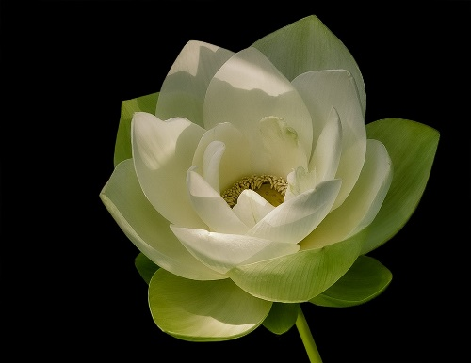

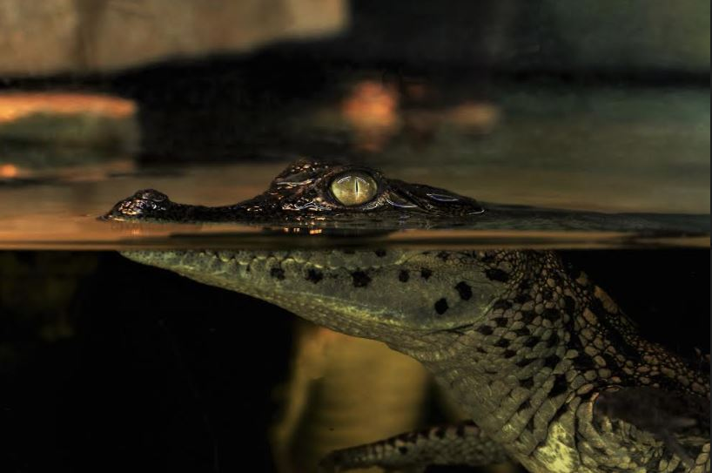
3rd Place
“Gator Level”
By Billy Ocker
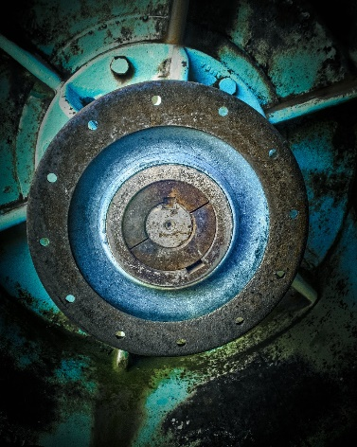

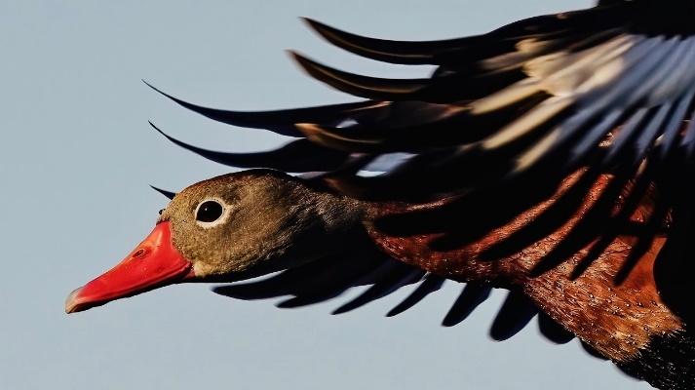

HM HM – “ Blue”
“Black Belly Whistler” By Mike Stewart
By Jerry Merritt
Class A: Monochrome

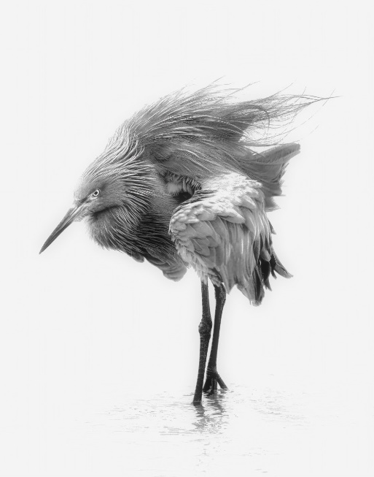

1st Place
“Angry Bird “
By Jerry Merritt

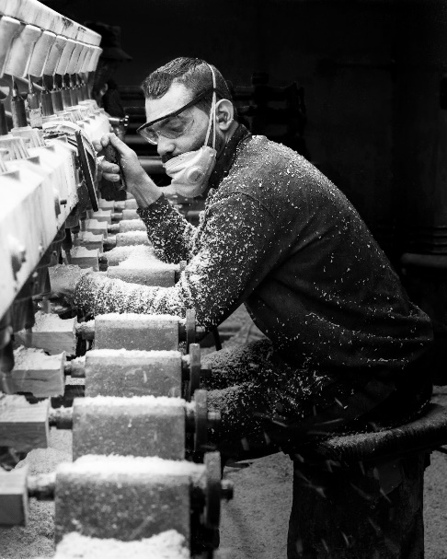
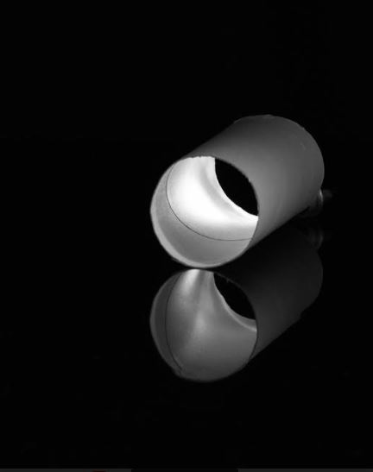

2nd Place
“Light at The End of The Tunnel”
By George Bollis

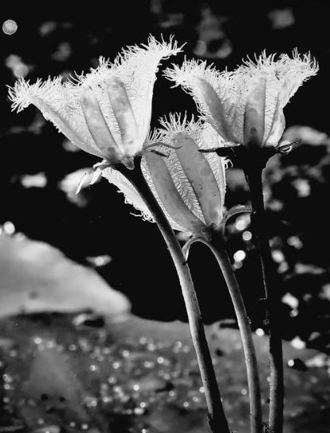
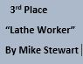

HM
“Water Snowflakes “
By Billy Ocker
Class A: Special Techniques

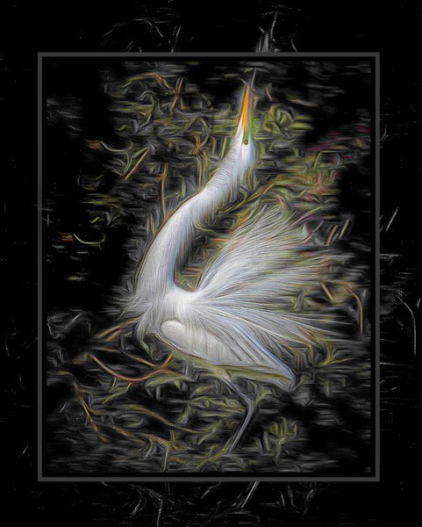

1st Place
“Egret Fantasy”
By Susan Grube

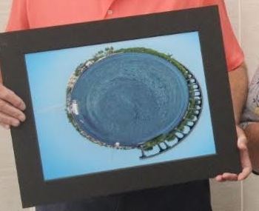

2nd Place
“Planet Vero”
By Dennis Ekman

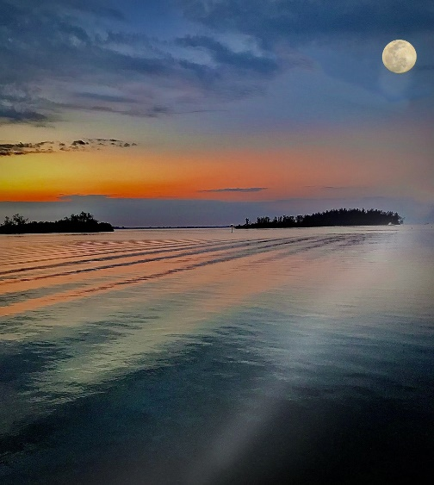

3rd Place
“Lagoon Moon”
By Skip Murphy

Indian River Photo Club
Slideshow July 2021
Theme - “Pots “
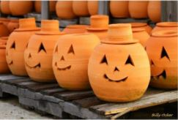

Send Your Photos to Bill Conway BY JULY 18th
At billcnwy@yahoo.com

Photo Contest for July 22nd
Theme - “Patriotic”

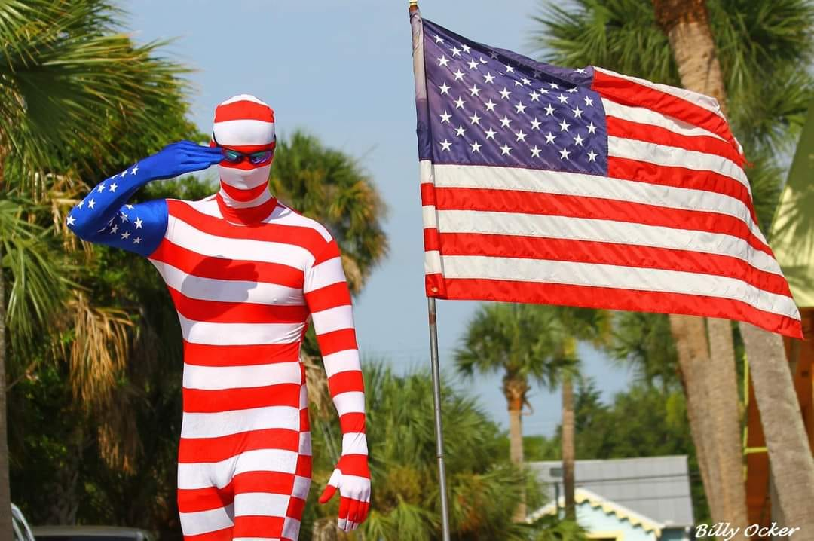

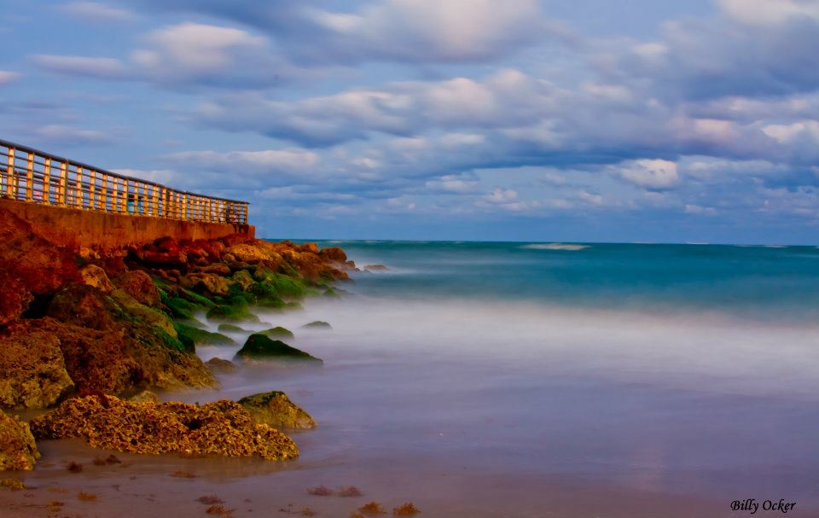

Club Outing
“Sebastian Inlet “
Date July 17th
Time: Sunrise to 10:30

The Club will be having its first Photography Outing of the year, and everyone is welcome to join in on the fun! There will be plenty of photos to capture. Sunrise, Surfers, wildlife, people and nature. Hope to see you all there!!

Things to Bring that you may need:

Camera
Tripod
Batteries
Sun Lotion
Hat
water

Billy’s Tips for Photography

1. Work Your Composition. Rules of thirds and leading lines
2. Make sure your Camera is on and ready
3. Learn Settings for still and moving objects
4. Don’t Overexpose Highlights.
5. Look for the best Light (Golden Hour)
6. Take Your Time. Look around for best angle
7. Move up and down. Take photos at different heights
8. Know When to Use a Tripod. Steady camera is always best

